< Virtual University Campus Event Management System (VUCEMS) >
Design Document

Version 1.0



Group Id: <F25PROJECT809A4 (BC230401227)>

Supervisor Name :< Hafiz Muhammad Azeem Sarwar >

Revision History
Date (dd/mm/yyyy) | Version | Description | Author
18/11/2025 | 1.0 | Introduction of the project  This document outlines the scope, functional and non-functional requirements, along with use case diagrams, work plan, ERD, database design, and interface design. | BC230401227

Table of Contents

- Introduction of document
- Scope (of the project)
- Functional Requirements Non Functional requirements
- Use Case Diagarm
- Work Plan
- Entity Relationship Diagram (ERD)
- Database Design
- Interface Design

- Introduction of Document
This document presents the complete requirements specification for the Virtual University Campus Event Management System (VUCEMS), a web-based application developed to simplify and enhance event-related activities within the Virtual University of Pakistan. The purpose of this document is to outline the system’s objectives, scope, features, and functionalities for all stakeholders, including students, faculty, organizers, and administrators. It provides a detailed description of the functional and non-functional requirements that guide the system’s design and development. VUCEMS aims to centralize event creation, promotion, registration, and feedback processes, ensuring efficient communication and improved event management. The document also defines different user roles, interactions, and system behaviors to ensure clarity and alignment among developers and stakeholders. By following this specification, the development team can build a reliable, user-friendly, and scalable platform that meets the university’s event management needs.
- Scope (of the project)
The scope of the Virtual University Campus Event Management System (VUCEMS) includes the design and development of a centralized web application that facilitates the creation, management, and participation in university events. The project covers all essential modules required by students, faculty organizers, and administrators to streamline event-related processes. For students, the system provides event browsing, registration, notifications, and feedback submission. For faculty and event organizers, it offers tools to create, update, and manage events, along with access to attendee lists and event statistics. Administrators are granted full control over user accounts, event categories, and system-wide analytics. The system will support secure authentication, responsive user interfaces, email alerts, and efficient data handling. The project does not include physical event logistics, third-party ticketing systems, or payment processing. The scope focuses solely on digital event management functionalities within the Virtual University environment.

- Functional Requirements Non Functional requirements

3. Functional Requirements
Public/Guest User
- Ability to view upcoming and active events.
- View detailed information for any event.
- Search and filter events by category, name, or date.
Student User
- Secure registration and login.
- Student dashboard showing registered events and suggestions.
- One-click event registration.
- View registration history.
- Receive email confirmation and reminders.
- Submit feedback for attended events.
Event Organizer / Faculty
- Secure login with organizer privileges.
- Create new events with full details (title, date, time, venue/link, capacity).
- Manage events (Create, Read, Update, Delete).
- View student registrations and export lists (CSV).
- Organizer dashboard with event statistics and feedback summary.
Administrator
- Full access to all organizer features.
- Manage users (view, edit, delete student/organizer accounts).
- Manage event categories (add, update, delete).
- View system-wide analytics (registrations, popular categories, event performance).
Non-Functional Requirements
Performance Requirements
- The system should load event listings within 3–5 seconds.
- Support multiple concurrent users without performance degradation.
- Efficient search and filtering within milliseconds.
Security Requirements
- User data must be encrypted and securely stored.
- Authentication using secure password hashing.
- Role-based access control (Student, Organizer, Admin).
- Prevent unauthorized access to restricted pages.
Usability Requirements
- Interface should be intuitive, responsive, and accessible.
- Mobile-friendly design for all user types.
- Clear navigation with consistent layouts.
Reliability & Availability
- System should maintain at least 99% uptime.
- Automatic recovery from common server errors.
- Regular backups of event and user data.
Maintainability
- Codebase should follow Laravel standards and modular structure.
- Easy to update event categories, user roles, and system settings.
Scalability
- System should handle an increasing number of events and users.
- Database optimized for growth and future expansions.

- Use Case Diagarm
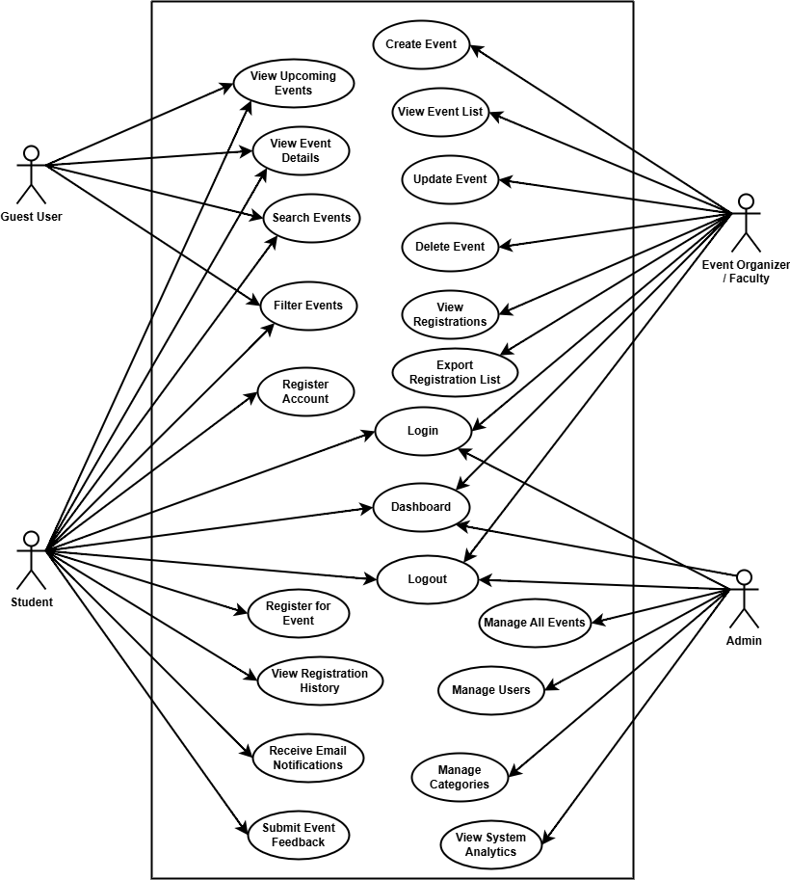

- Work Plan
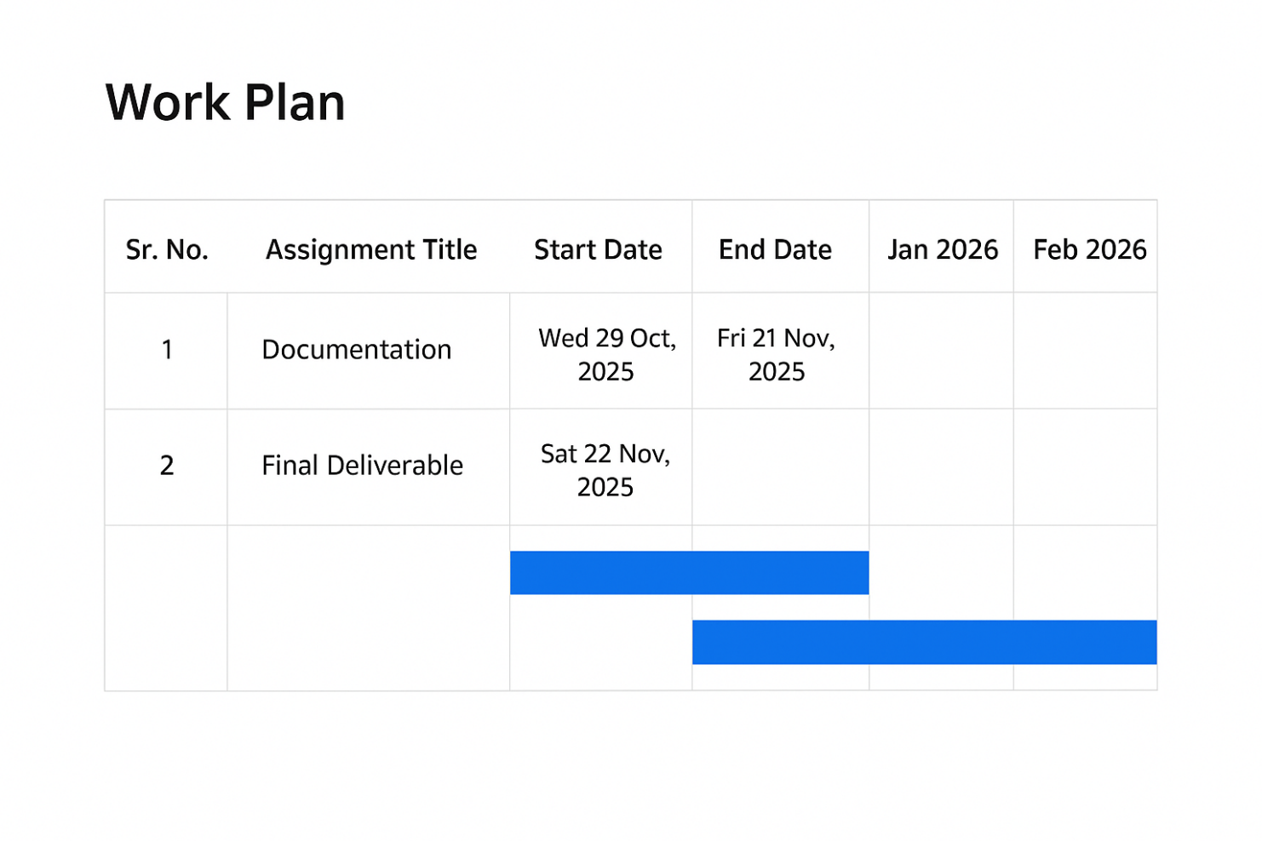

- Entity Relationship Diagram (ERD) (To be developed using Microsoft Visio or any other drawing software of your choice)
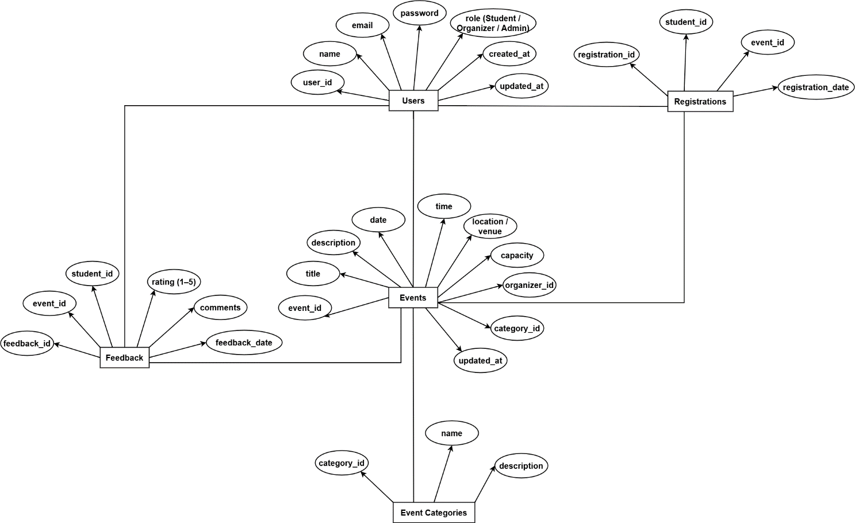

- Database Design

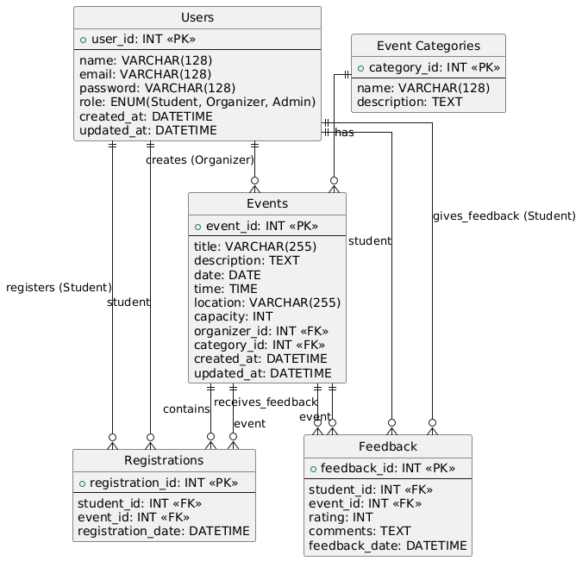

- Interface Design

